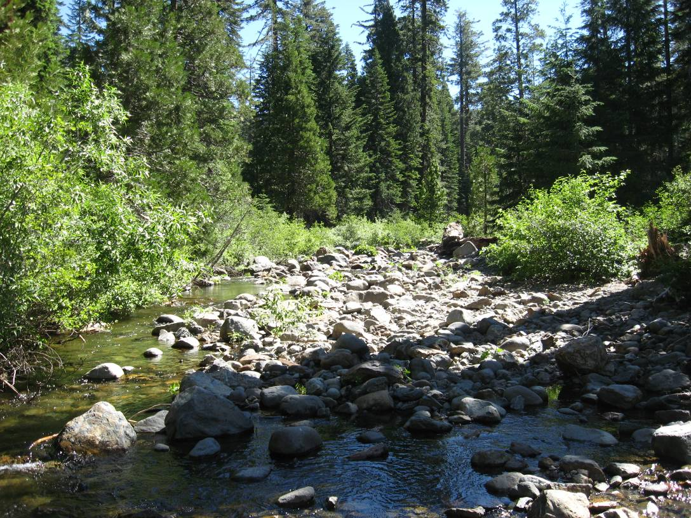
Photo 1. Particle Size Region 1, looking upstream along main channel of Duncan Creek flowing into the diversion pool.
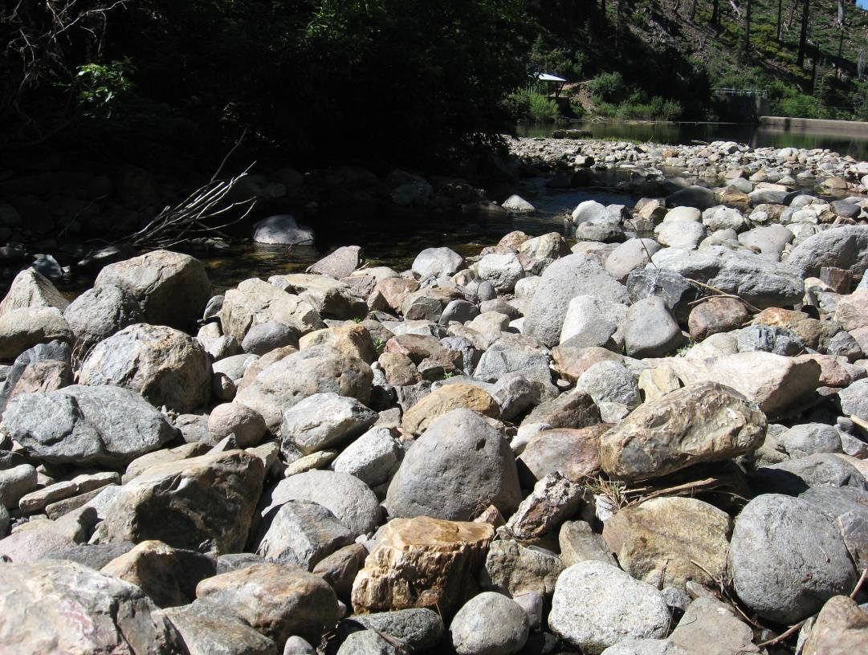
Photo 2. Particle Size Region 1, close-up of cobble dominated bed material within the main channel.
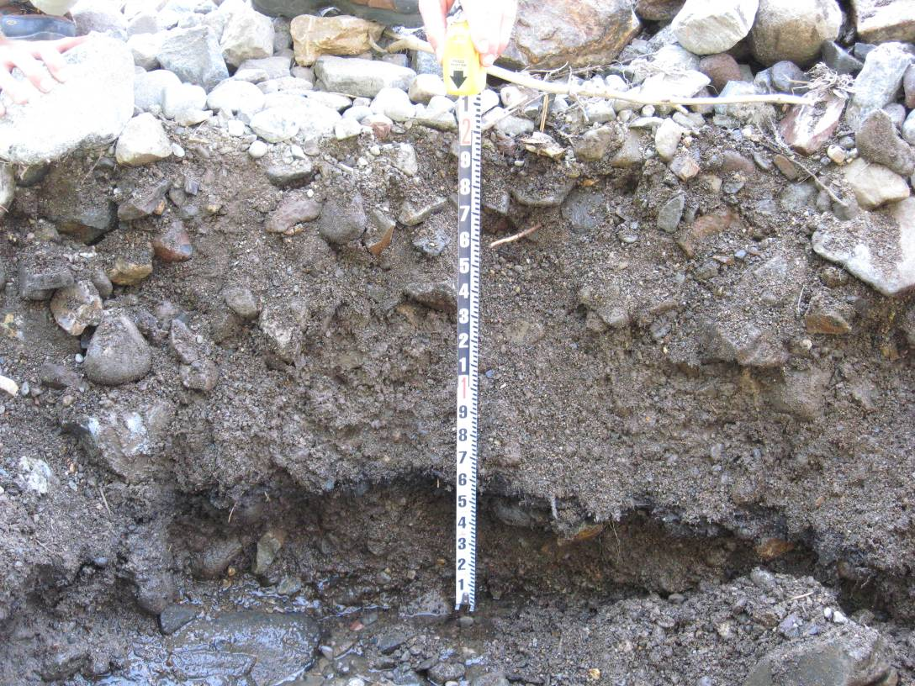
Photo 3. Particle Size Region 1, sediment deposition profile.
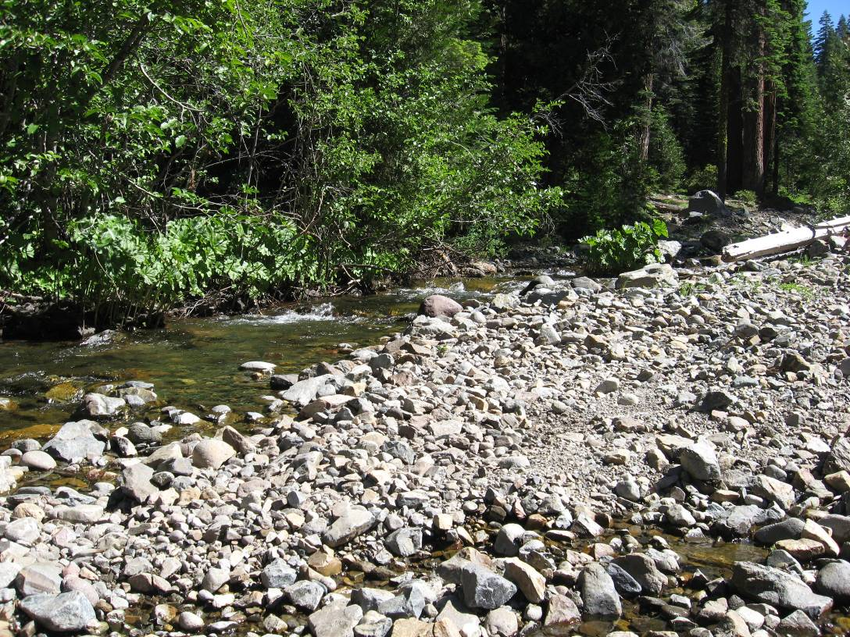
Photo 4. Particle Size Region 2, looking upstream along main channel of Duncan Creek flowing into the diversion pool.
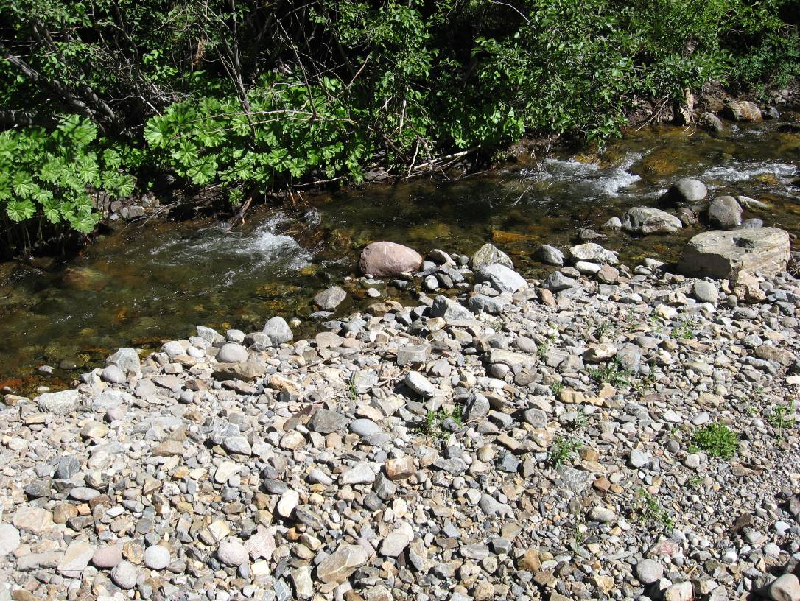

Photo 5. Particle Size Region 2, close-up of gravel-cobble dominated bed material.
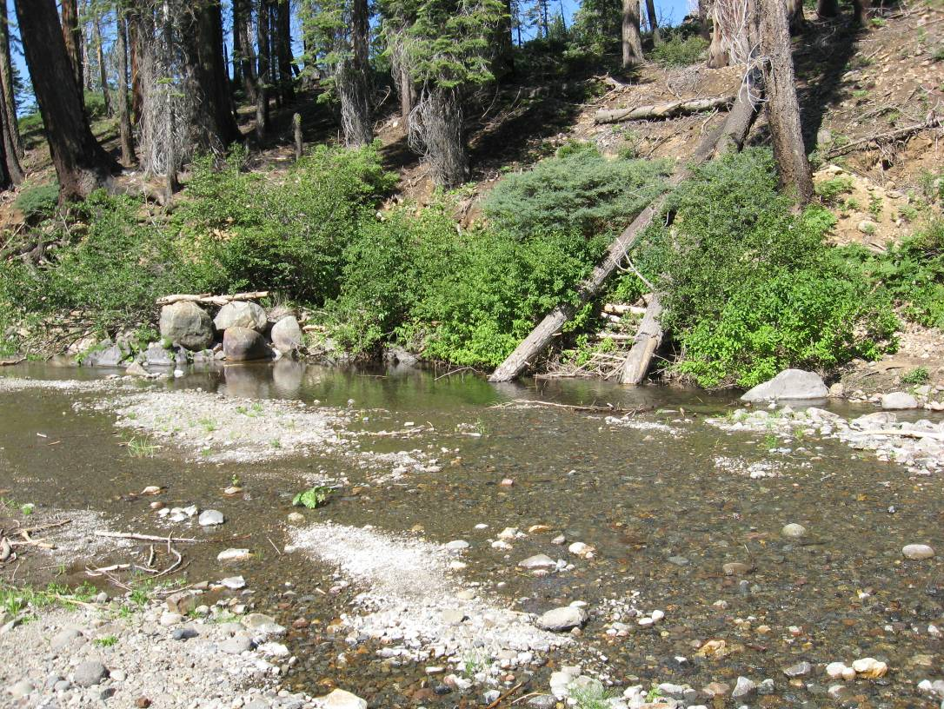
Photo 6. Particle Size Region 3, main channel of Duncan Creek as it flows into the diversion pool.
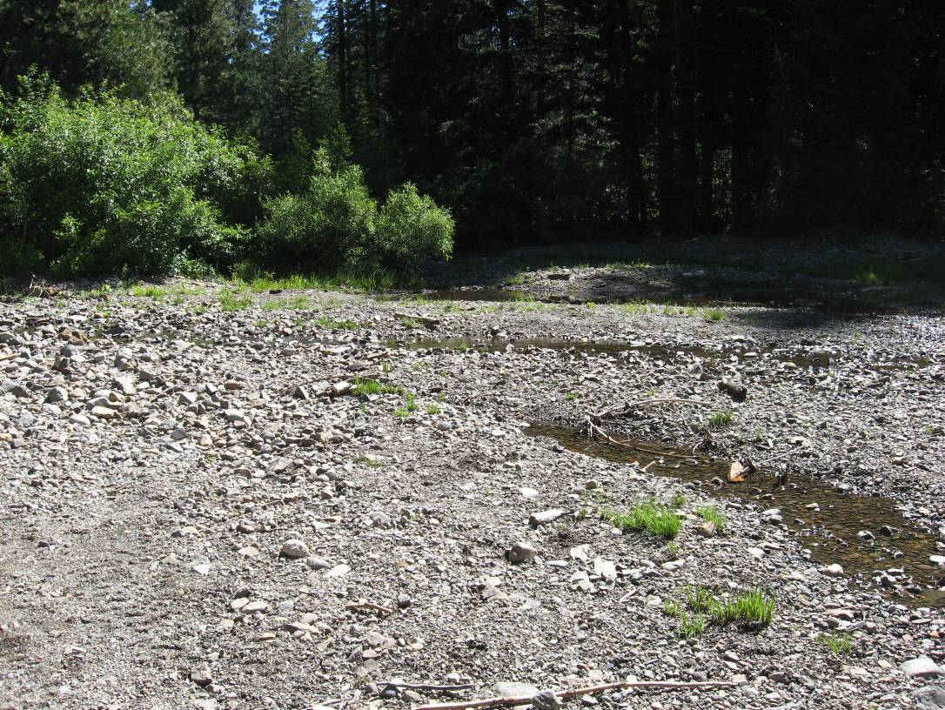
Photo 7. Particle Size Region 3, looking across the exposed bed of the diversion pool.
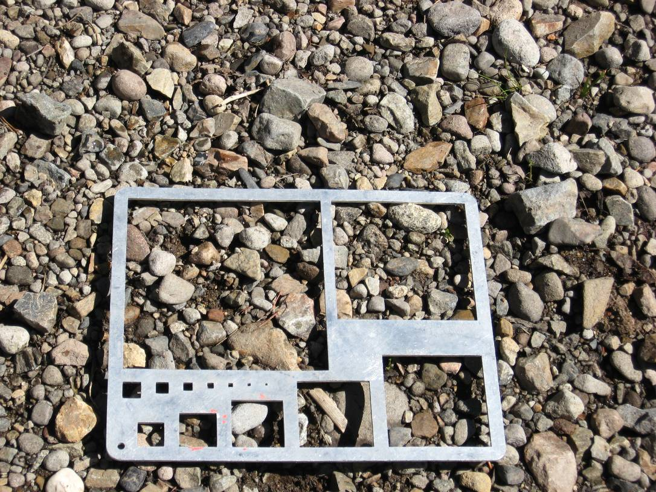
Photo 8. Particle Size Region 3, close-up of gravel dominated bed material.
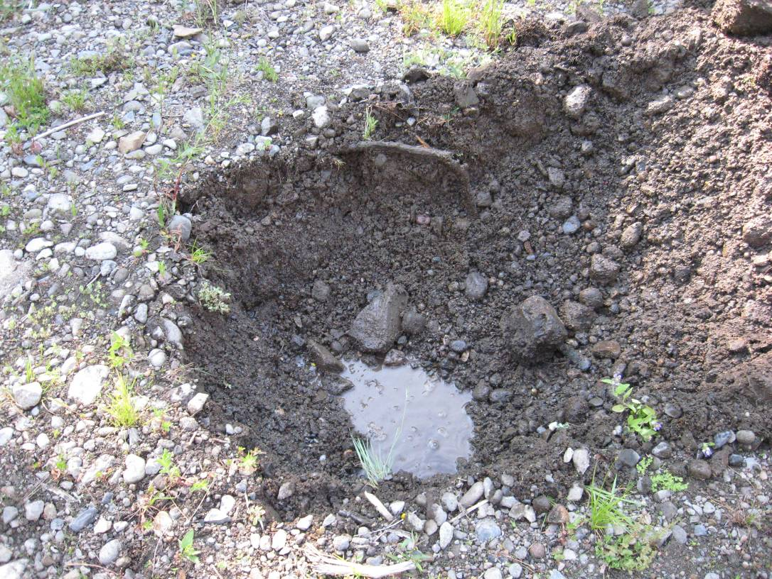
Photo 9. Particle Size Region 3, Pit #1, sediment deposition profile with groundwater less than 1 foot below surface.
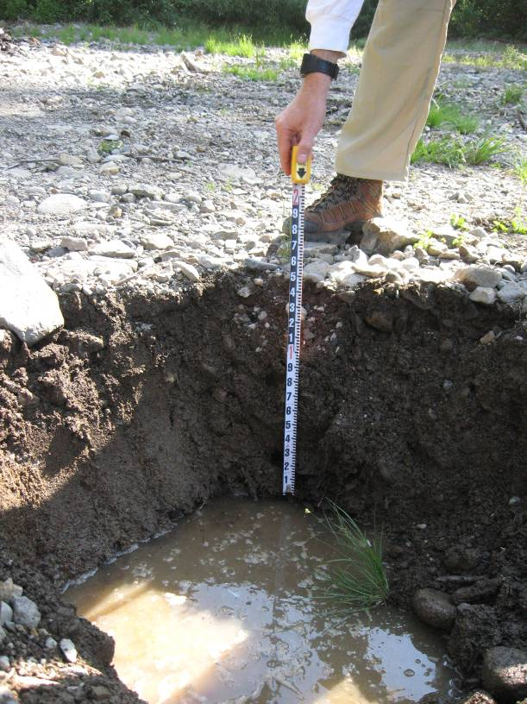
Photo 10. Particle Size Region 3, Pit #2, sediment deposition profile with groundwater approximately 1.5 feet below the surface.
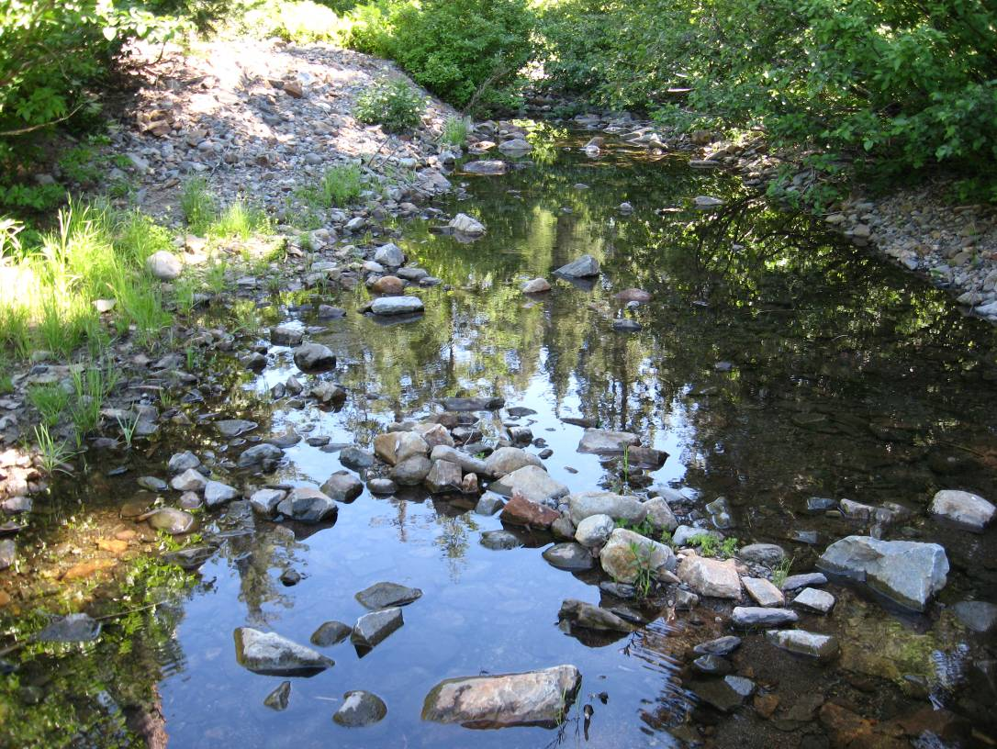
Photo 11. Particle Size Region 4, looking upstream along the secondary channel of Duncan Creek as it flows into the diversion pool.
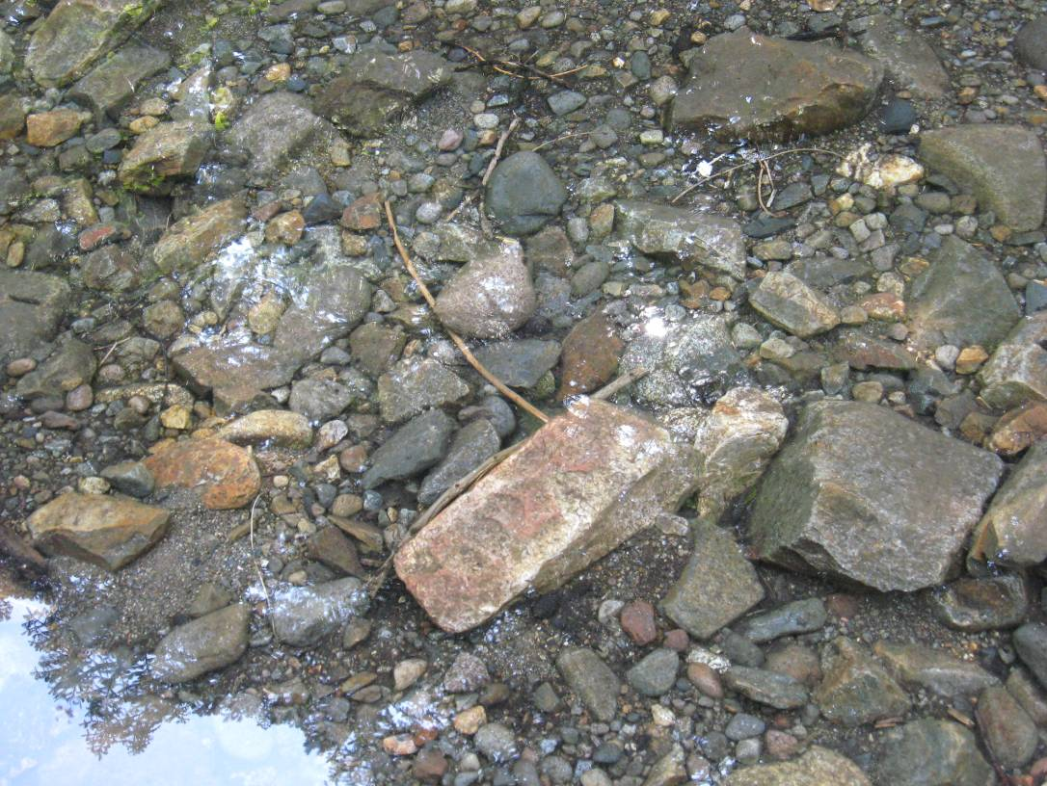
Photo 12. Particle Size Region 4, close-up of gravel-cobble dominated bed material.
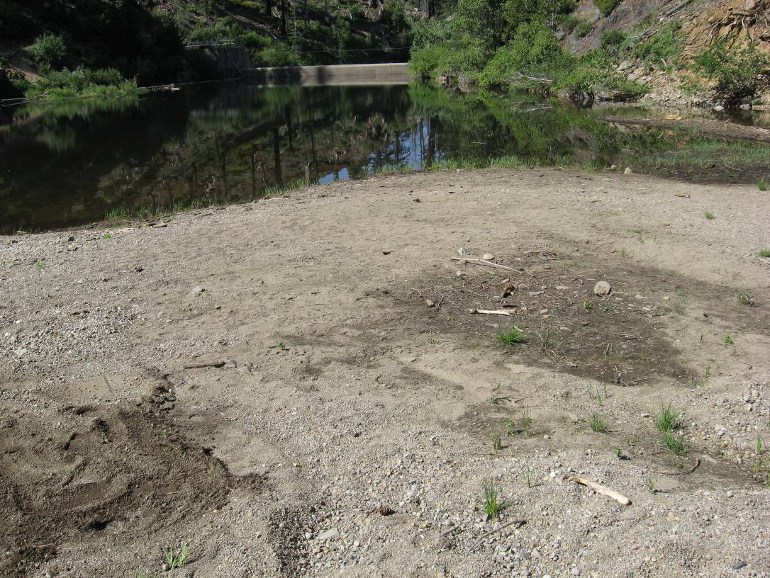
Photo 13. Lower-most portion of the exposed bed dominated by sand, within the diversion pool.
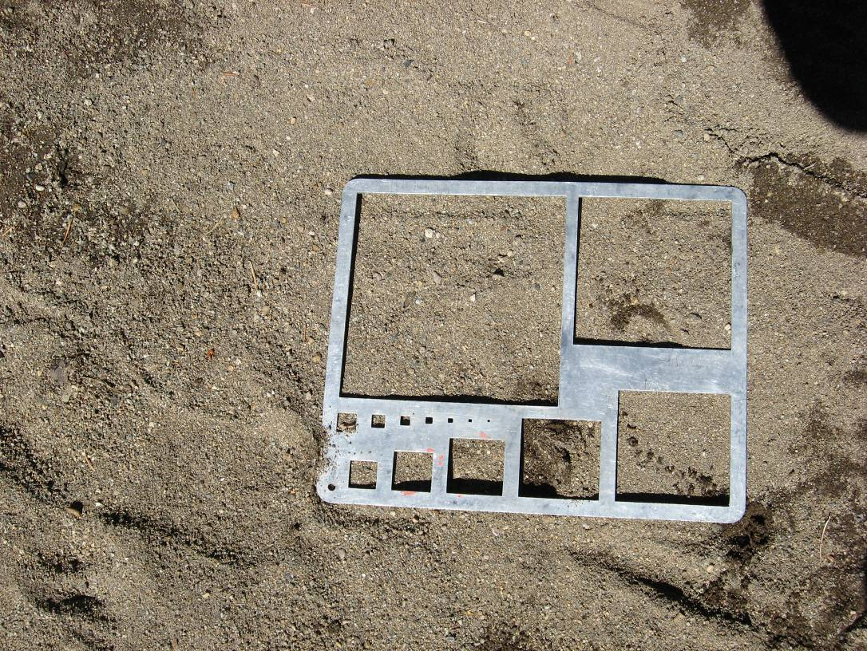
Photo 14. Close-up of sand dominated bed material.

